**Project Design Phase-II**

**Technology Stack (Architecture & Stack)**

|  |  |
| --- | --- |
| **Date** | 28 October 2022 |
| **Team ID** | PNT2022TMID22731 |
| **Project Name** | Web Phishing Detection |
| **Maximum Marks** | 4 Marks |

**Technical Architecture:**

The Deliverable shall include the architectural diagram as below and the information as per the table1 & table 2

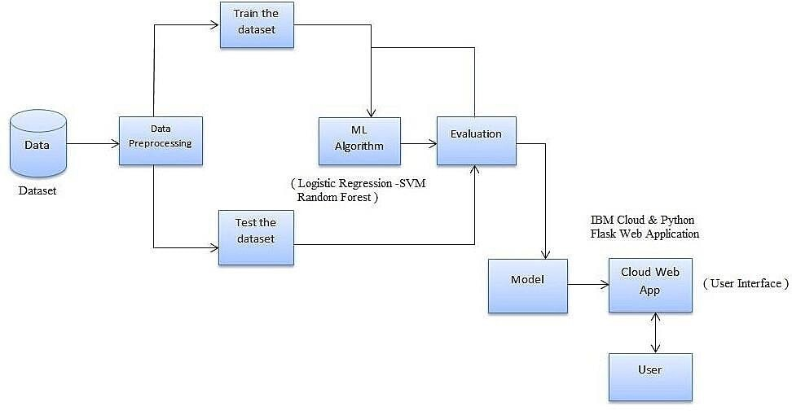

**Table-1 : Components & Technologies:**

|  |  |  |  |
| --- | --- | --- | --- |
| **S.No** | **Component** | **Description** | **Technology** |
| 1. | User Interface | Web Application, Cloud UI | HTML, CSS, JavaScript / Angular Js / React Js etc. |
| 2. | Applicati on Logic-1 | Machine Learning Algorithms such as Random forest, Decision Tree,  Logistic Regression and SVM. Python Flask Application for Web App | Java / Python |
| 3. | Applicati on Logic-2 | IBM Watson Speech to Text technology enables fast and accurate speech transcription in multiple languages for a variety of use cases, including but not limited to customer self - service, agent assistance and speech analytics. | IBM Watson STT service |
| 4. | External API-1 | IBM Watson Studio is used to run the junketeer notebook | IBM Watson Studio |
| 5. | External API-2 | In order to train the model we can use of Machine  Learning Service | Machine Learning Service |
| 6. | Applicati on Logic-3 | The IBM Watson Assistant service combines machine learning, natural language understanding, and an integrated dialog editor to create conversation flows  between your apps and your users. | IBM Watson Assistant |
| 7. | Database | Stored Procedure (EXEC) | MySQL, NoSQL, etc. |
| 8. | Cloud Database | Database Service on Cloud | IBM DB2, IBM Cloud ant etc. |
| 9. | File Storage | File storage requirements | IBM Block Storage or  Other Storage Service or Local File system |

|  |  |  |  |
| --- | --- | --- | --- |
| 10. | Machine  Learning Model | Machine Learning Model is used in order to predict the website | Logistic Regression Model |
| 11. | Infrastructure  (Server / Cloud) | Application Deployment on Local System / Cloud | IBM Cloud |

**Table-2: Application Characteristics:**

|  |  |  |  |
| --- | --- | --- | --- |
| **S.No** | **Characteristics** | **Description** | **Technology** |
| 1. | OpenSource  Framewor  ks | Go phish is a powerful, open-source phishing framework that makes it easy to test your organization's exposure to phishing. | Machine Learning |
| 2. | Security Implementatio  ns | In our prototype we use encryption techniques and security algorithms on web application | AES 256, Confines PDR |
| 3. | Scalable Architecture | Scalability is high due to accuracy provided by the model and Responsive  UI/UX | React Framework, jQuery, Bootstrap, Cloud flare |
| 4. | Availability | Available at NLP, Spam Detection, Blacklisting or Reporting, and machine learning techniques | Acuteness, Intruder, Ghost Phisher |
| 5. | Performance | Deployed and tested with multiple algorithms and this system gives greater accuracy and better performance than other. | Deep Learning |